Project Quality Management Plan
Project Title: intelligent re-commerce system | Project Number: xxx
Project supervisor: Dr. Pranita Upadhyay | Anticipated Project Start Date:
Project leader/manager: Razeev dahal | Date Prepared:
Quality Management Strategy

Quality management for our project has been performed throughout the project lifecycle with special attention to:
- Quality Planning – primarily during the project planning process.
- Quality Assurance (QA) – primarily during the project execution process.
- Quality Control (QC) – primarily during the project monitoring and controlling process.

Quality Planning:
Tools:

- Benchmarking:

Here as a benchmarking example we have taken the famous e-commerce website Amazon.

amazon is an American e-commerce and cloud computing organization, established in Seattle, Washington DC, its headquarters. In offering goods for sales, Amazon takes its customer services as a top priority. Amazon believes in establishing and maintaining long-term relationships with its customers in order to encourage repeat visits and buying, and even earning customer referrals. Additionally, the Company constantly seeks to achieve steady communication with its customers and also earn great feedback from them in order to continually improve their stores and services.
In order to achieve what they do:
Amazon offers a number of e-mail addresses to ensure customers can request for information that bothers them, and also to encourage suggestions and feedbacks. In addition to this, Amazon provides customers with telephone services, therefore, users or customers can access the customer service representatives through the telephone 24 hours a day, and 7 days a week. Moreover, to ensure the quality of services provided by the customer service is prompt and professional enough to meet customer demands, Amazon has automated some specific tools utilized by its customer support staff and also constantly planning for future enhancements. (“Amazon Reports”)

- Cause and effect diagram:
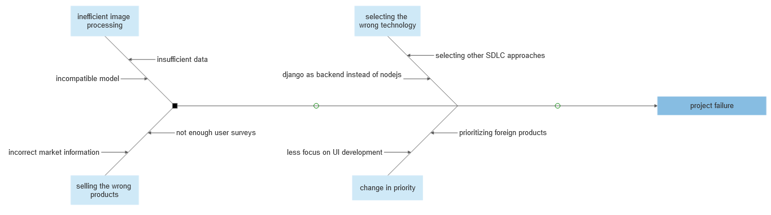
Fig:cause and effect(fishbone) diagram for e-commerce

- Cost of Quality(COQ)
It is the total cost of efforts to achieve an acceptable level of product/service quality

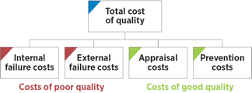

For our project:
- Appraisal costs :

- Internal failure costs :

- External failure costs :

- Prevention costs :

Quality Assurance
The focus of quality assurance is on the processes used in the project. Quality assurance ensures that project processes are used effectively to produce quality project deliverables..

The following table identifies:
- The project processes subject to quality assurance.
- The quality standards and stakeholder expectations for that process.
- The quality assurance activity – e.g., quality audit or reviews, code review - that will be executed to monitor that project processes are properly followed.
- How often or when the quality assurance activity will be performed.
- The name of the person responsible for carrying out and reporting on the quality assurance activity.

Project Process |  | Process Quality Standards/  Stakeholder Expectations |  | Quality Assurance Activity | Frequency/Interval |  | Who is Responsible
Requirement analysis | Developers have completely understood project requirements. |  | Peer review of software requirements specification. |  |  | weekly |  | All members.
Set realistic time and budget estimates | Minimum budget and time requirements |  | Inspect project features |  |  | weekly |  | All members
Programming the functionalities | Project functionalities satisfies project requirements |  | Verification and testing |  |  | weekly |  | All members
Security features | Project is secure and negates external attacks |  | Proper security measures implementation |  |  | weekly |  | All members

Quality audits:
Following quality audits are required by our project:
- Prequalification/pre-selection audits
- Project Manager audits requested by the client
- General internal project audits
- Unplanned audits in reaction to a request or incident

After the quality assurance, the final review is conducted. The outcome of the review can be one among the below three:

- Approved: No change is required

- Further changes may be required and again quality review has to do be made

3. Changes may also be required in the E-Commerce system developed

Quality Control
Quality control involves monitoring specific project results to determine if they comply with relevant standards and identifying ways to eliminate causes of unsatisfactory results.

Tools:

Pareto analysis:

It is the analysis based on the principle that “80% of our sales come from 20% of our clients” or “80% of complaints are from 20% of clients” also known as “80/20” rule.

The diagrammatical representation of pareto analysis is done through pareto diagrams. For our project we have analysed the error count to problem specifications:

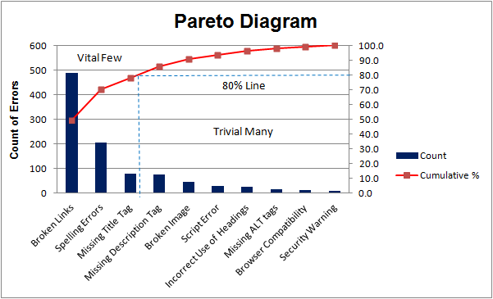

Control charts:

The below control chart for preventing defects & allowing to determine whether the process is in control or out of control.
